Create a Product class write a query add and update and delete products.

1.Created table

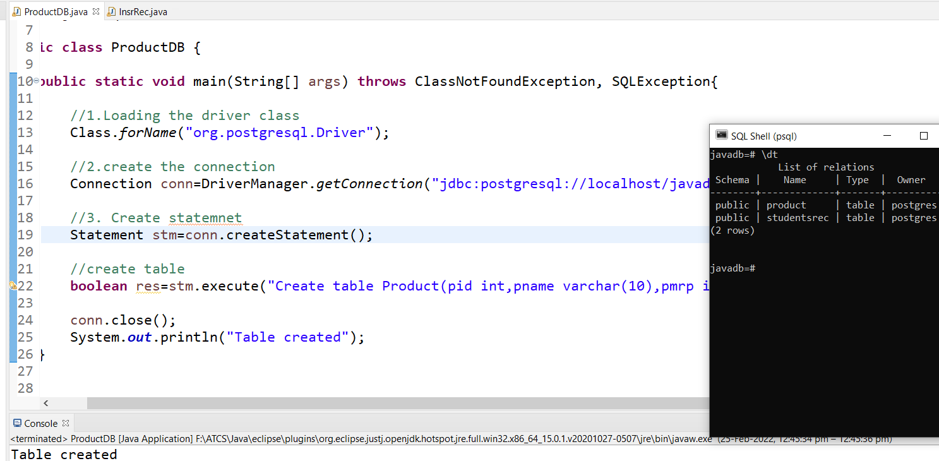

2. Insert values

Add query

Delete Query

CRUD operations on Pizza add,update,delete,create.

